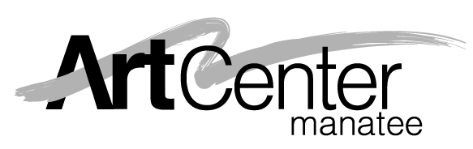

ArtCenter Manatee Scholarship Program
Student Scholarship Application 2024

FULL AND PARTIAL SCHOLARSHIPS MAY BE AVAILABLE.
Please complete form and send to ArtCenter Manatee

(Please Print)
Student Name: ___ Date of Birth:

Student’s School: Age:

Parent(s) or Legal Guardian(s):

Home Phone: Work Phone: Other Phone:

Email: ________________________

Street Address:

City: State: Zip Code:

Scholarship Request for which class or program:

Date of class/program: Scholarship Amount Requested:

Please explain why you are requesting a scholarship:

Parent/Guardian requesting scholarship must attach a current tax return.
(We recommend you block out all Social Security numbers.)

Family’s Estimated Total Monthly Income: $ /month

Job Title & Other Sources of Income:

Secondary Source of Income:

Do you qualify for any government programs (food stamps, Medicaid, etc.)? Yes No

Has your child(ren) received a scholarship from ArtCenter Manatee before? Yes No Unsure

Continues on next page

Who referred you to the ArtCenter Scholarship Program?

Name Relation to Student

Personal Reference:
Name Phone Relation to Student

Signature of Parent or Guardian Date

ArtCenter Manatee does not discriminate against any person on the basis of race, color, national origin, disability, age or sexual orientation in admission or participation in its programs, activities, or in employment.

FOR OFFICE USE ONLY:

Date received: Date Reviewed:

Scholarship was: _____ approved in the amount of: $ _________

_____ denied because________________________________________

_________________________________________________________

Date Applicant was Notified: __________________ By: __________________________

________________________________________________________________________
Signature of ArtCenter Director Date

Student Attended: _________________________________________________________

Name of Class/Program: __________________________________________________

Student Evaluation completed by: _______________________ Date: __________
Signature of Instructor

________ Evaluation Attached.

ArtCenter Manatee
209 9th St W, Bradenton, FL
941-746-2862
artcentermanatee.org
email: acm@artcentermanatee.org

